Pokhara University

Level: Bachelor | Semester – Spring | Year : 2005
Programme: BE |  | Full Marks : 100
Course: Applied Mechanics |  | Time : 3hrs.

Candidates are required to give their answers in their own words as far as practicable.
The figures in the margin indicate full marks.

Attempt all the questions.

1. | - Explain the concept particles, rigid body and free body diagram. What are the guidelines for drawing a good free body diagram?  - The rectangular platform is hinged at A and B and supported by a cable which passes over a frictionless hook at E. Knowing that the tension in the cable is 2000N, determine the moment about each of the co-ordinate axes of the force exerted by the cable at D.  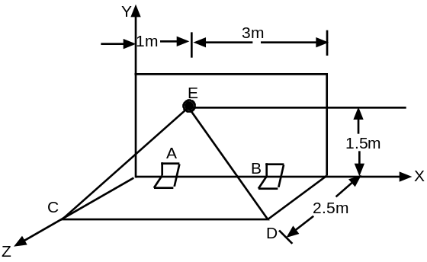 | 2+2+2+2  7
2. | a) Determine the second moment of area of an isosceles triangle of height h and base b with respect to its base by integration.  OR  Determine the centroid of area bounded by curve y² = 4x, and line y = x by direct integration.  b) What should be the value of θ in figure which will make the motion of 900 N block down the plane to impend? The coefficient of friction for all contact surfaces is 1/3. Also determine the tension in the cable.  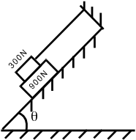 | 7  8
3. | - The peripheral speed of the tooth of a 250 mm diameter circular saw blade is 45m/sec. When the power to saw is turned off the speed of the tooth decreases at a constant rate and the blade comes to rest in 9 sec. Determine the time at which the total acceleration of the tooth is 40 m/sec².  - A golfer hits a golf ball with an initial velocity of 50 m/s at an angle of 25º with the horizontal. Knowing that the fairway slopes downward at an angle of 5º, determine the distance d between the golfer and point B where the ball lands.  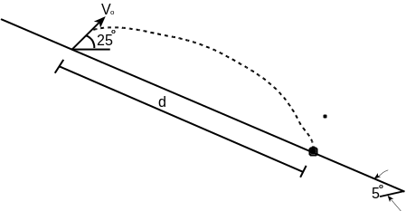 | 7  8
4. | a) A system consists of three particles A, B, and C. Given m_{A} = 5 kg, m_{B} = 4 kg, m_{C} = 3 kg and that the velocities of the particles expressed in m/s are, respectively, 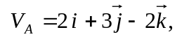 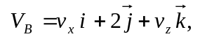 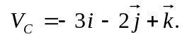 Determine the components v_{x} and v_{z} of the velocity of particle B for which the angular momentum H₀ of the system about O is parallel to the x axis. Determine the corresponding value of H_{o}.  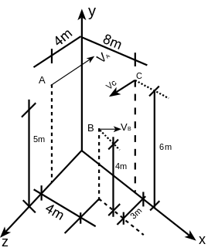  OR  Explain the conservation of energy for a system of particles from work energy principle. | 8
 | b) The relation for r and θ for the motion of a particle is given by r = 2θ² and θ = t² where r is in meters, θ is in radians and t is in seconds. Find the velocity and acceleration of the particle when θ = 0.5 radians.  OR  Define an expression for the tangential and normal components of the acceleration of the body in a curvilinear motion. | 7
5. | A 1.5 kg block is attached to an undeformed spring of constant K = 80 N/m and is resting on a horizontal frictionless surface when it is stuck by an identical block A moving at a speed of 5 m/sec. Considering successively the cases when the coefficient of restitution between the two blocks is (i) e = 1, (ii) e = 0 determine the maximum deflection of the spring, and the final velocity of block A.  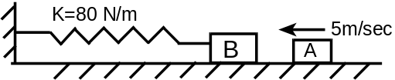 | 15
6. | The double pulley shown has a total mass of 6 kg and a centroidal radius of gyration of 140 mm. Five collars, each of mass 1.5 kg, are attached to cords A and B shown in figure below. When the system is at rest and in equilibrium, one collar is removed from cord A. Knowing that the bearing friction is equivalent to a couple M of magnitude 0.5 N-m, determine the velocity of cord A after it has moved 900 mm.  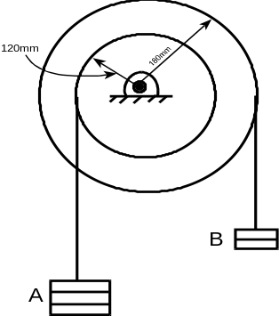  OR  A homogeneous sphere S and a uniform cylinder C are in contact when they are released from rest on the incline shown below. Knowing that both the objects roll without slipping: determine after 4 seconds of motion the clear distance between the cylinder and the sphere.  SA  CA  10⁰ | 15  15
7. | Write short notes on (Any Two):  - Projectile motion b) Moment of inertia  c) Impact d) D'Alemberts Principle | 2x5

